Road Accident Risk Prediction and High-Risk Zone Identification Using Machine Learning in R

Question 1: How does the number of road accidents vary across different hours of the day?
Formula — Accident Frequency
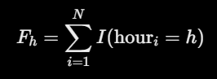
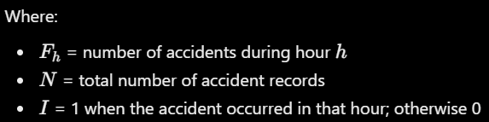
Chart 1: Line chart
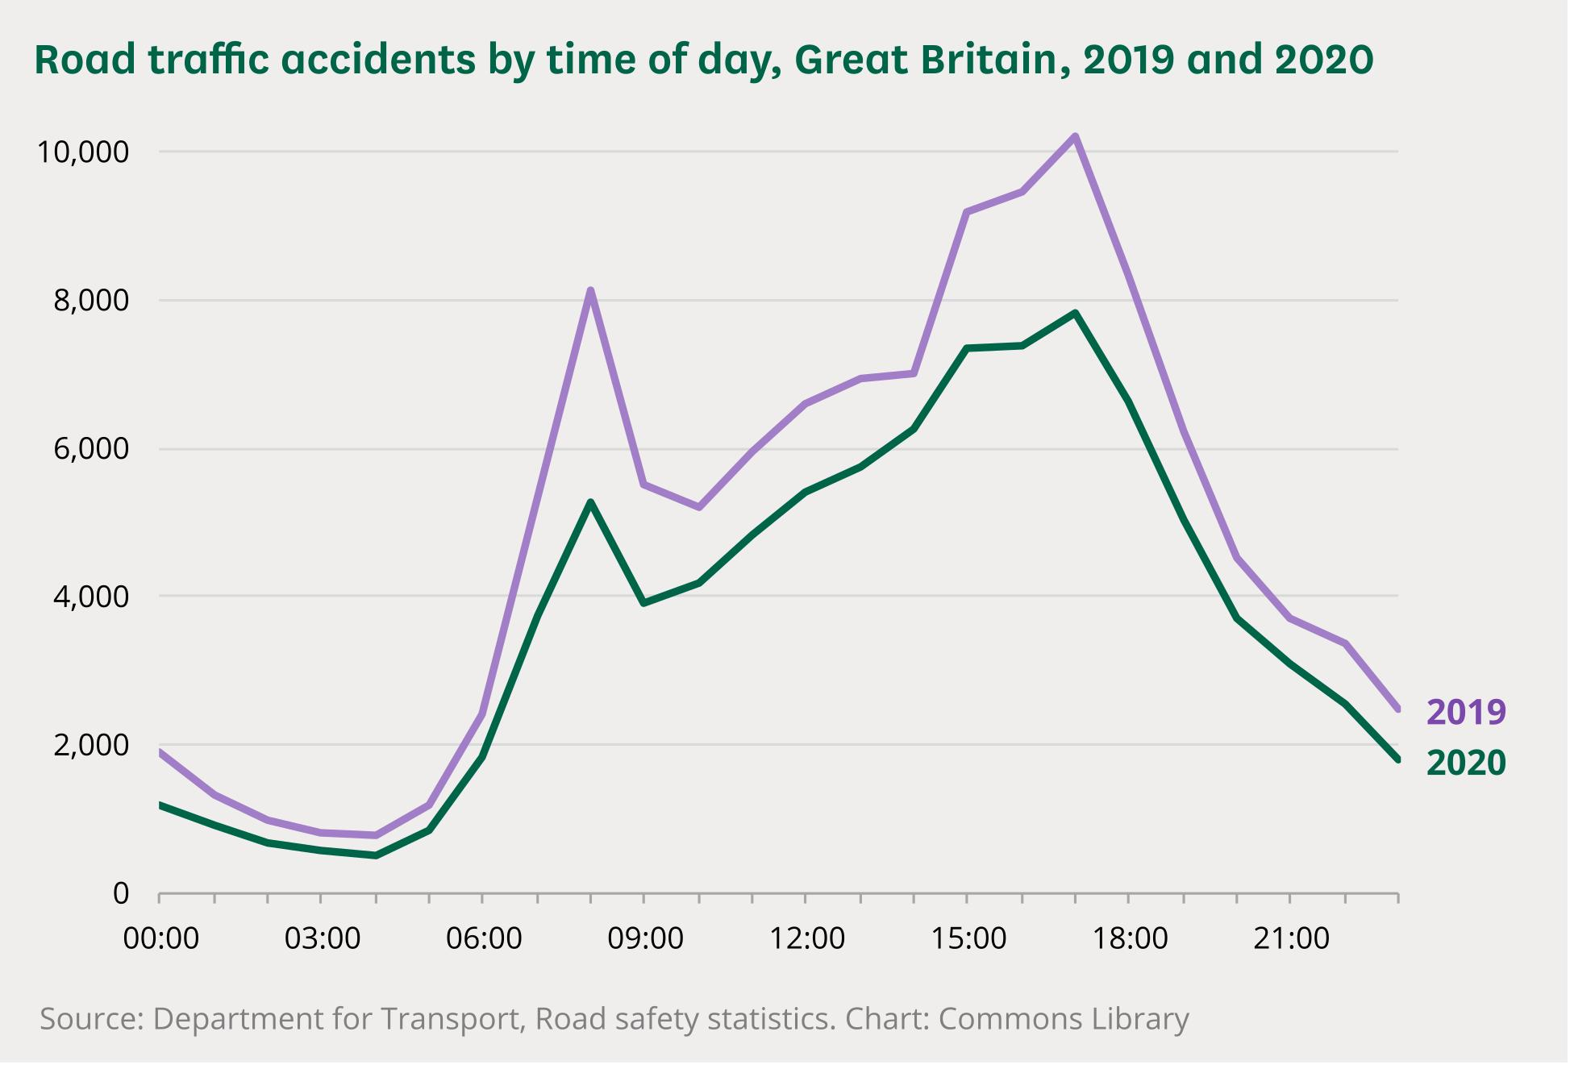
The line chart shows how accident frequency changes throughout the day and helps identify peak accident hours.

Question 2: What proportion of accidents belongs to each weather condition?
Formula — Weather-wise Accident Percentage
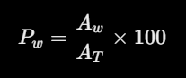
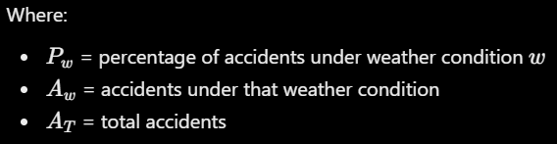
Chart 2: Pie chart
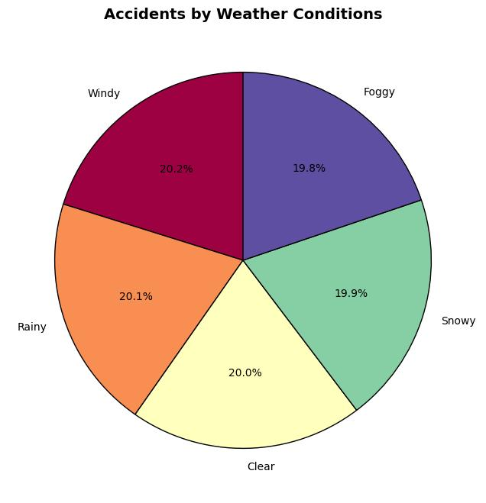
The pie chart compares the share of accidents occurring in clear, rainy, foggy, misty, and stormy conditions.
Question 3: What is the distribution of speed limits associated with recorded accidents?
Formula — Mean Speed Limit
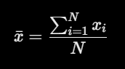
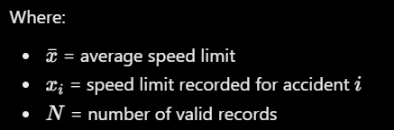
Chart 3: Histogram
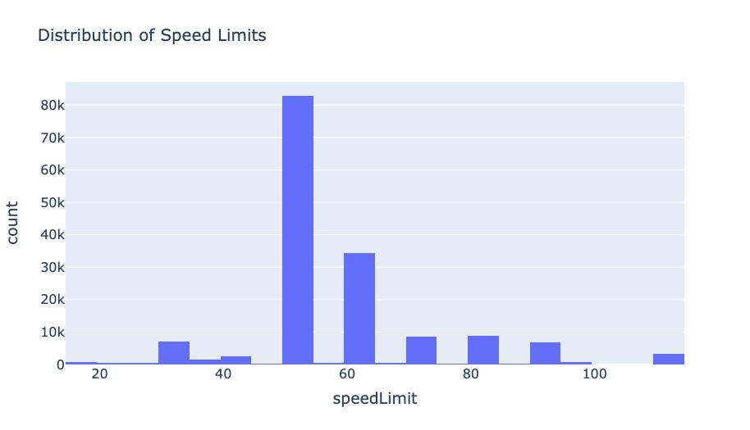
The histogram shows how frequently accidents occur at different recorded speed limits.
Question 4: How does casualty count vary across accident severity categories?
Formula — Interquartile Range (IQR)

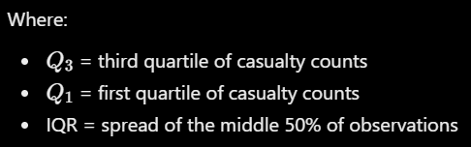
Chart 4: Box plot
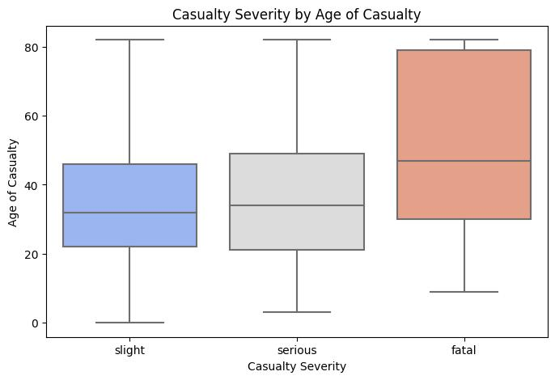
The box plot compares casualty distributions across severity categories, showing the median, quartiles, spread, and potential outliers.
Question 5: Is there a relationship between speed limit and the number of casualties?
Formula — Pearson Correlation Coefficient
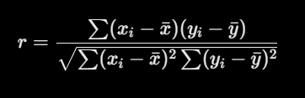
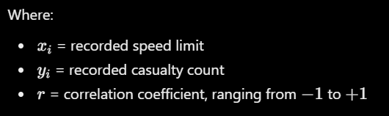
Chart 5: Scatter plot
